Docker Build Guide

This system uses four Docker containers, each serving a different purpose:
- RabbitMQ Docker
Used as the message broker — a middleware component for sending and receiving RFID data.
- React Docker
Runs the UI (display + control panel) — showing cabinet status and sending commands.
- Module Configuration Docker
Provides a UI for modifying cabinet configuration (hostname, location, reboot) by sending messages through MQTT.
- Azure Service Docker
Sends the same data that is sent over MQTT, but stores and forwards it using Azure Service Bus.
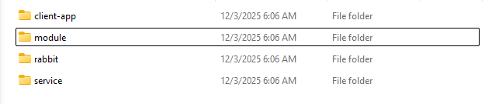

1. RabbitMQ Docker
--------------------------------------------------------
Steps
- Open the rabbit folder.
- Run the following commands in CMD.
#Build Image:
docker build -t custom-rabbitmq .

#Run Container:
docker run -d --name rabbitmq -p 5672:5672 -p 15672:15672 -p 8883:8883 -p 1883:1883 -p 15675:15675 custom-rabbitmq

#Enable Auto-Restart:
docker update --restart unless-stopped rabbitmq

--------------------------------------------------------
2. React Docker
--------------------------------------------------------
Steps
- Open the client-app folder.
- Run the following commands in CMD.

#Build Image
docker build -t client-app .

#Run Container
docker run -d -p 3000:3000 -p 3001:3001 ^
-e HOST_IP=192.168.137.1 ^
-e NUMBER_OF_CABINETS=2 ^
--name client-app client-app

#Enable Auto-Restart:
docker update --restart unless-stopped client-app

--------------------------------------------------------
3. Module Configuration Docker
--------------------------------------------------------
Steps
- Open the Module folder.
- Run the following commands in CMD.

#Build Image
docker build -t modulesensor .
#Run Container
docker run -d --name modulesensor -p 5100:5100 ^
-v "%cd%\module.json:/app/module.json" ^
-v "%cd%\sensor_data.db:/app/sensor_data.db" ^
modulesensor
#Enable Auto-Restart
docker update --restart unless-stopped modulesensor
--------------------------------------------------------
4. Azure Service Docker
--------------------------------------------------------
Steps
- Open the Service folder.

Before Building: Extract node_module. If node_modules.tar is included, extract it first.
tar -xf node_modules.tar

#Build Image
docker build -t startservice .

#Run Container
docker run -d --name azureservice -v "%cd%:/app" -p 5000:5000 -p 5200:5200 startservice

#Enable Auto-Restart
docker update --restart unless-stopped azureservice

